Start State

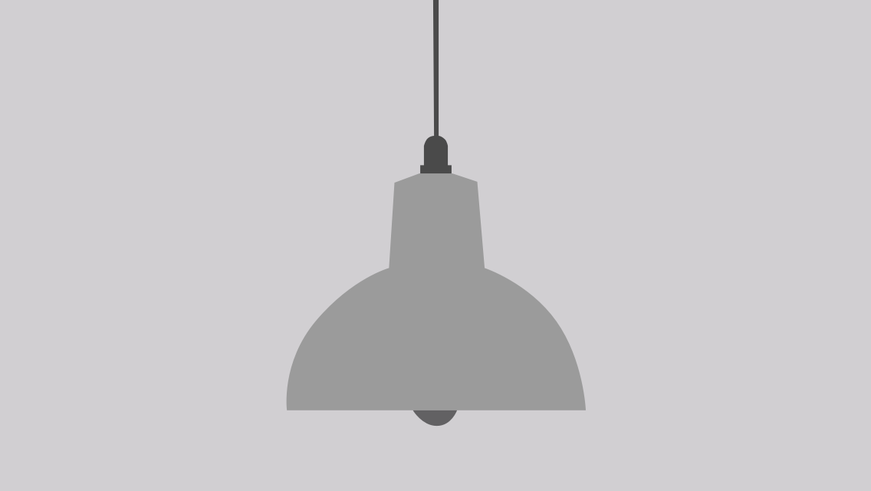

**Right answer1**



Pink #FFBED2

Dark Pink #E13268

Green #00BFB7

Dark Green #205755

**Right answer 2**



Dark Blue #3E8EAA

light Blue #E0F7FF

Orange #F8BB00

Dark Orange #A68729

**Right answer 3**



Light Yellow #F9F3C6

Yellow #F6DD1B

Dark Purple #936FA3

Purple #CCABDB